Patient Health History Form PENINSULA PHYSICAL THERAPY & ASSOCIATES, INC
Name : ________________________________ Body Part: ____________________________________ Date: ________________
Occupation: _____________________________Interests/Hobbies: _____________________________________________________
Are you currently receiving ANY form of home health care? YES NO For: _____________________________________________
Next scheduled appointment with Dr.: __________________ Physician name: ____________________________________________
QUESTIONS ABOUT YOUR CONDITION:
When did your condition begin? Give specific date of injury or onset of pain: _____________________________________________
Did you have surgery? YES NO When: _____________ Type of Surgery: _____________________________________________
Did you have any of the following tests? (check all applicable) __ XRAY __MRI __CT Scan __EMG __Other
Have you received physical therapy in the past? YES NO Same condition? YES NO
Where: _________________________________ When: ___________ Who referred you to PPT&A: _______________________
Are you currently taking any medications? YES NO Please list ( Use the back of the page if you need more space): ____________________________________________________________________________________________________________
Are you in PAIN? If so, DRAW on the BODY CHART where your pain is located:
What does your pain feel like? (check all that apply)
__ SHARP __ BURNING __ ACHING __ TINGLING __ NUMBNESS – OTHER ___________________________________
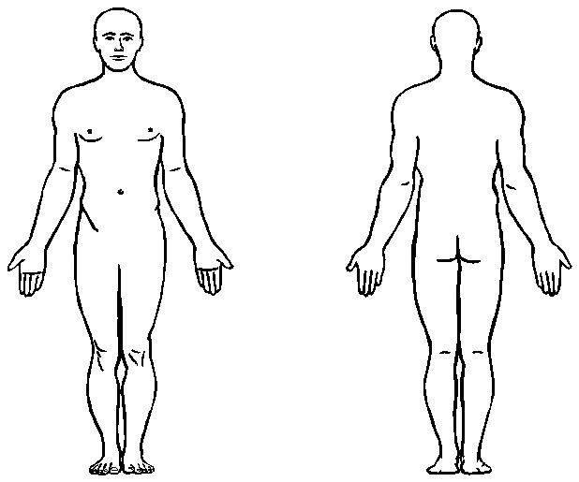
Does pain radiate to the arms or legs? YES NO
Does pain keep you up at night? YES NO
Rate your PAIN on a 0 to 10 scale: (0 = no pain, 10 = severe pain)
0 1 2 3 4 5 6 7 8 9 10 (circle one)
What makes your pain worse? 0 1 2 3 4 5 6 7 8 9 10 (circle one)
__ LYING __SITTING __STANDING __WALKING __ OTHER _________________________________________________________________________________
What relieves your PAIN? 0 1 2 3 4 5 6 7 8 9 1 0 (circle one)
__ LYING DOWN __SITTING __STANDING __WALKING __ OTHER ____________________________________________
Activity level: __ LOW __ MEDIUM __ HIGH Recent weight loss or gain? YES NO How much?__________________
Do you have any health conditions we should be aware of ? _______________________________________________________
Are you sensitive to heat/ICE? YES NO Are you pregnant? YES NO Is your pain due to a car accident? YES NO
Do you have now, or have you had any of the following? (check all that apply)
__ Heart Disease __ Heart Attack __ Stroke __ High Blood Pressure __ Seizures
__ Diabetes __ Pacemaker __ Headaches __ Kidney Disease __ Thyroid problems
__ Cancer __ Hernia (any) __ Previous surgery __ Metal implants __ Dizziness
__ Nervous Disorders _Allergies __ Infectious Disease __ Asthma / Shortness of Breath
If YES to any of the above, please provide details and approximate dates: ____________________________________________________________________________________________________________
All of the above statements are true to my best knowledge. : _________________________________________________________
PATIENT'S SIGNATURE AND DATE

